C) **Simple Harmonic Motion**

SOURCE CODE:

clc

clear

clf

A = input("initial displacememt:")

x0=[A;0]

t0=0;

T=2*%pi *//*sqrt(m/k)*

t=0:0.01:T

function **p**=f(**t**, **x**)

**p**(1)=**x**(2)

**p**(2)=-**x**(1)

endfunction

x=ode(x0,t0,t,f)

a=gca()

a.box="on"

a.x_location="origin";

a.y_location="origin";

plot2d(t,x(1,:),1)

ylabel("Displacement","fontsize",2)

xlabel("Time","fontsize",2)

title("SHM","fontsize",5)

OUTPUT:

i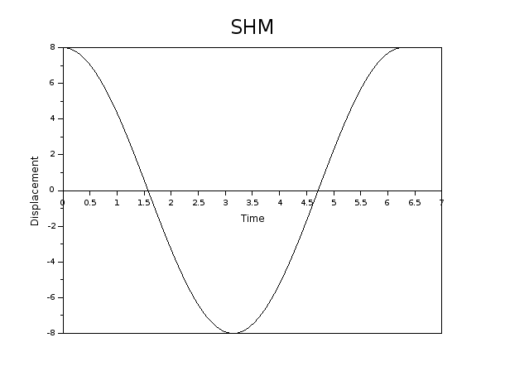nitial displacememt:8